

# 

### Semester Two Examination, 2019

### Question/Answer booklet

# MATHEMATICS

**APPLICATIONS**

**UNITS 3 AND 4**

## Section One:

## Calculator-free

Your name : _________________________________

## Time allowed for this section

Reading time before commencing work: five minutes

Working time: fifty minutes

## Materials required/recommended for this section

***To be provided by the supervisor***

This Question/Answer booklet

Formula sheet

***To be provided by the candidate***

Standard items: pens (blue/black preferred), pencils (including coloured), sharpener,  
correction fluid/tape, eraser, ruler, highlighters

Special items: nil

## Important note to candidates

No other items may be taken into the examination room. It is **your** responsibility to ensure that you do not have any unauthorised material. If you have any unauthorised material with you, hand it to the supervisor **before** reading any further.

## Structure of this paper

|  |  |  |  |  |  |
| --- | --- | --- | --- | --- | --- |
| Section | Number of questions available | Number of questions to be answered | Working  time (minutes) | Marks available | Percentage of examination |
| Section One:  Calculator-free | 8 | 8 | 50 | 52 | 35 |
| Section Two:  Calculator-assumed | 13 | 13 | 100 | 98 | 65 |
|  | | |  | **Total** | 100 |

|  |  |  |
| --- | --- | --- |
| Markers use only | | |
| Question | Maximum | Mark |
| 1 | 4 |  |
| 2 | 6 |  |
| 3 | 7 |  |
| 4 | 6 |  |
| 5 | 7 |  |
| 6 | 7 |  |
| 7 | 7 |  |
| 8 | 8 |  |
| S1 Total | 52 |  |
| S1 Wt (×0.6731) | 35% |  |
| S2 Wt | 65% |  |
| Total | 100% |  |

## Instructions to candidates

1. The rules for the conduct of examinations are detailed in the school handbook. Sitting this examination implies that you agree to abide by these rules.

2. Write your answers in this Question/Answer booklet preferably using a blue/black pen.  
Do not use erasable or gel pens.

3. You must be careful to confine your answer to the specific question asked and to follow any instructions that are specified to a particular question.

4. Show all your working clearly. Your working should be in sufficient detail to allow your answers to be checked readily and for marks to be awarded for reasoning. Incorrect answers given without supporting reasoning cannot be allocated any marks. For any question or part question worth more than two marks, valid working or justification is required to receive full marks. If you repeat any question, ensure that you cancel the answer you do not wish to have marked.

5. It is recommended that you do not use pencil, except in diagrams.

6. Supplementary pages for planning/continuing your answers to questions are provided at the end of this Question/Answer booklet. If you use these pages to continue an answer, indicate at the original answer where the answer is continued, i.e. give the page number.

7. The Formula sheet is not to be handed in with your Question/Answer booklet.

Section One: Calculator-free 35% (52 Marks)

This section has**eight (****8)** questions. Answer **all** questions. Write your answers in the spaces provided.

Working time: 50 minutes.

Question 1 (4 marks)

Graph $G$ is shown below.

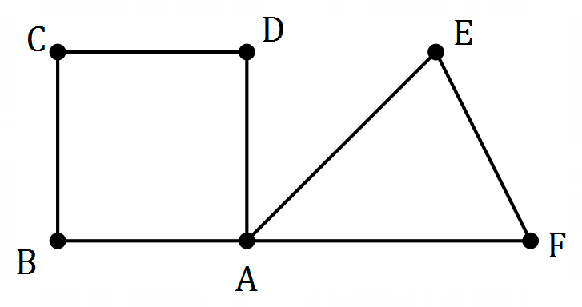

(a) State the length of the shortest cycle in $G$ and list the vertices in this cycle. (2 marks)

(b) State the length of the longest Hamiltonian path in $G$ and list all possible starting vertices for this path. (2 marks)

Question 2 (6 marks)

The weights on the graph below are the costs, in hundreds of dollars, to connect adjacent offices (represented by the vertices) to a new IT system.

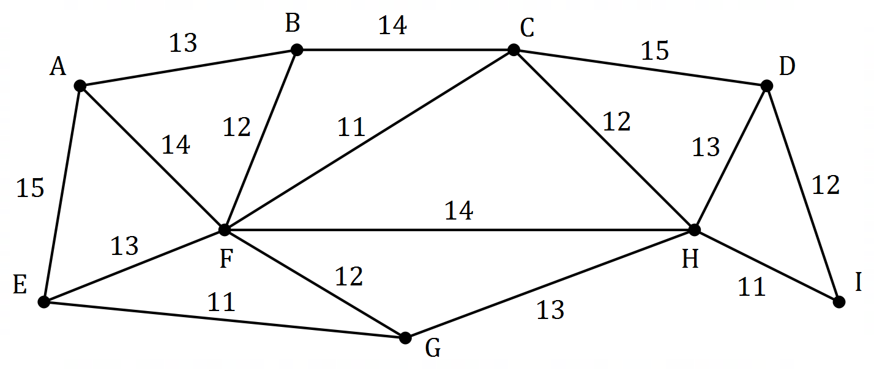

(a) Cleary indicate the minimum spanning tree on the graph above. (2 marks)

(b) Determine the cost of connecting the offices to the new IT system using the minimum spanning tree. (2 marks)

(c) An IT consultant recommends that the new system must include a connection between office $A$ and office $B$, and between office $A$ and office $E$. Determine the minimum cost of connecting all the offices using a spanning tree that includes these two edges. (2 marks)

Question 3 (7 marks)

(a) Graph $G_{1}$ below has $5$ vertices.

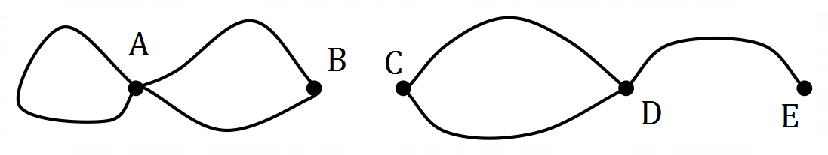

(i) Construct an adjacency matrix from $G_{1}$. (2 marks)

(ii) Give two reasons that $G_{1}$ is not simple. (2 marks)

(b) Graph $G_{2}$ below has $6$ edges.

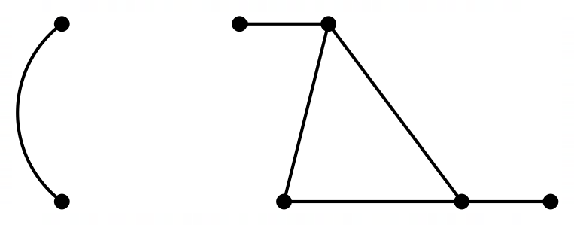

(i) Without adding any more vertices, add the minimum possible number of edges to $G_{2}$ so that it is Eulerian and Hamiltonian. (2 marks)

(ii) State the difference in length of the Eulerian trail and Hamiltonian cycle in the modified $G_{2}$. (1 mark)

Question 4 (6 marks)

The time series plot below shows the number of trees sold by a garden centre over $15$ 
 consecutive days at the start of September. Day $1$ was a Sunday.

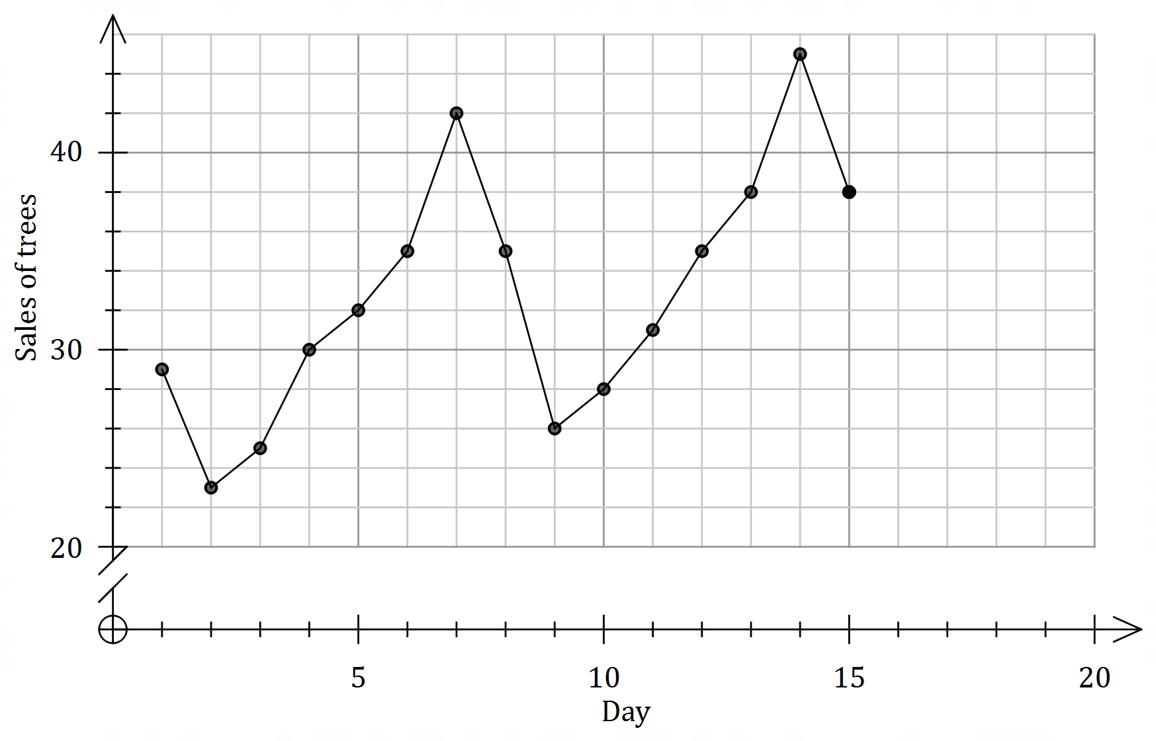

(a) On days $16$, $17$ and $18$ the centre sold $28$, $33$ and $36$ trees respectively. Use this data to complete the time series plot. (2 marks)

(b) Describe the trend and seasonality displayed in the time series plot. (2 marks)

(c) Besides trend and seasonality, fluctuations within a time series are often due to a third factor. Briefly discuss this factor. (2 marks)

Question 5 (7 marks)

The digraph below shows the possible routes that a car can take to reach freeway entry $F$ after they leave carpark $A$. The weights on each edge represent the maximum number of cars that can travel between adjacent intersections (vertices) every minute.

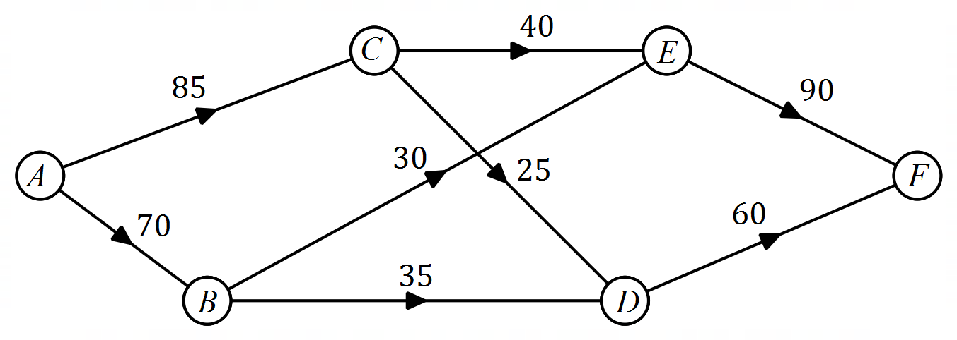

(a) Determine the maximum number of cars that can travel from $A$ to $F$ every minute.

(3 marks)

(b) Determine, with justification, the maximum increase in the flow of cars every minute from $A$ to $F$ that could be achieved by adding a new route

(i) from $A$ to $D$ that can carry up to $40$ cars per minute. (2 marks)

(ii) from $C$ to $F$ that can carry up to $30$ cars per minute. (2 marks)

Question 6 (7 marks)

The quarterly sales of a drilling machine are shown in the table below.

|  |  |  |  |  |  |  |  |  |
| --- | --- | --- | --- | --- | --- | --- | --- | --- |
| Year | $$2017$$ | | | $$2018$$ | | | | $$2019$$ |
| Quarter | $$2$$ | $$3$$ | $$4$$ | $$1$$ | $$2$$ | $$3$$ | $$4$$ | $$1$$ |
| Sales | $$24$$ | $$22$$ | $$27$$ | $$30$$ | $$23$$ | $$18$$ | $$24$$ | $$-$$ |

(a) Calculate the $4$-point centred moving average for quarter $1$ of $2018$. (2 marks)

(b) Determine the sales for quarter $1$ of $2019$ given that the $3$-point moving average for quarter $4$ of $2018$ was $25$. (2 marks)

(c) Moving averages are often calculated to smooth out time series data. Explain why this is useful. (1 mark)

(d) The figures in the table clearly indicate that for one of the seasons, the deseasonalised sales will be higher than the actual sales. Name this season and explain your answer.

(2 marks)

Question 7 (7 marks)

A company sells water coolers and each day allocates staff to call businesses and make sales in its four sales regions. One staff member is assigned to one region for the whole day.

One day, only three sales staff turn up to work and the manager must decide how to allocate them to maximise the total number of sales made. The table below shows the expected number of sales each staff member will make in each region.

|  |  |  |  |  |  |
| --- | --- | --- | --- | --- | --- |
|  | | Sales Region | | | |
| $$P$$ | $$Q$$ | $$R$$ | $$S$$ |
| Staff | Jay | $$33$$ | $$37$$ | $$39$$ | $$35$$ |
| Kai | $$24$$ | $$25$$ | $$26$$ | $$21$$ |
| Leo | $$39$$ | $$38$$ | $$40$$ | $$38$$ |

(a) Show use of the Hungarian algorithm to determine the optimum allocation of staff to regions in order to maximise sales on this day. (6 marks)

(b) State the total number of sales on this day using your allocation from (a). (1 mark)

Question 8 (8 marks)

A project consists of activities $A_{1}$ to $A_{10}$. The duration and immediate predecessors for each activity are shown in the table below.

|  |  |  |  |  |  |  |  |  |  |  |
| --- | --- | --- | --- | --- | --- | --- | --- | --- | --- | --- |
| Activity | $$A_{1}$$ | $$A_{2}$$ | $$A_{3}$$ | $$A_{4}$$ | $$A_{5}$$ | $$A_{6}$$ | $$A_{7}$$ | $$A_{8}$$ | $$A_{9}$$ | $$A_{10}$$ |
| Duration (minutes) | $$15$$ | $$12$$ | $$8$$ | $$6$$ | $$11$$ | $$12$$ | $$10$$ | $$9$$ | $$12$$ | $$8$$ |
| Immediate predecessors | $$-$$ | $$-$$ | $$A_{1}$$ | $$A_{1}$$ | $$A_{2}$$ | $$A_{2}$$ | $$A_{1}$$ | $$A_{3},A_{4}$$ | $$A_{3},A_{4}$$ | $$A_{5},A_{6},A_{7}$$ |

(a) Complete the network below to represent the durations and interdependencies of all the activities in the project. (2 marks)

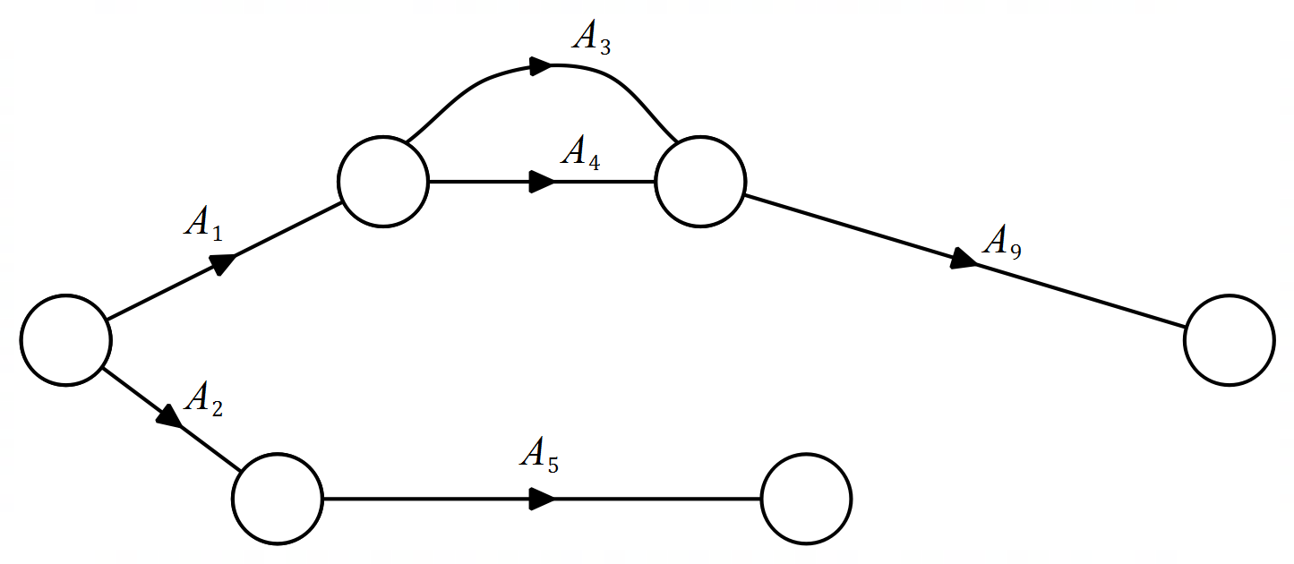

(b) Determine the earliest starting time for $A_{10}$. (1 mark)

(c) List, in order, the activities that lie on the critical path and state the minimum completion time for the project. (2 marks)

(d) Determine the latest starting time for $A_{5}$. (1 mark)

(e) If the duration of $A_{5}$ was increased by $5$ minutes, what effect, if any, would this have on the critical path and minimum completion time? (2 marks)

Supplementary page

Question number: _________

© 2019 WA Exam Papers. Kennedy Baptist College has a non-exclusive licence to copy and communicate this document for non-commercial, educational use within the school. No other copying, communication or use is permitted without the express written permission of WA Exam Papers. SN245-146-1.